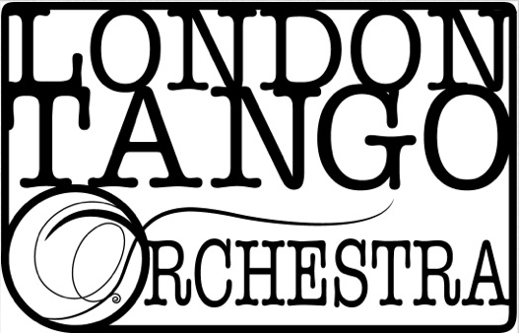

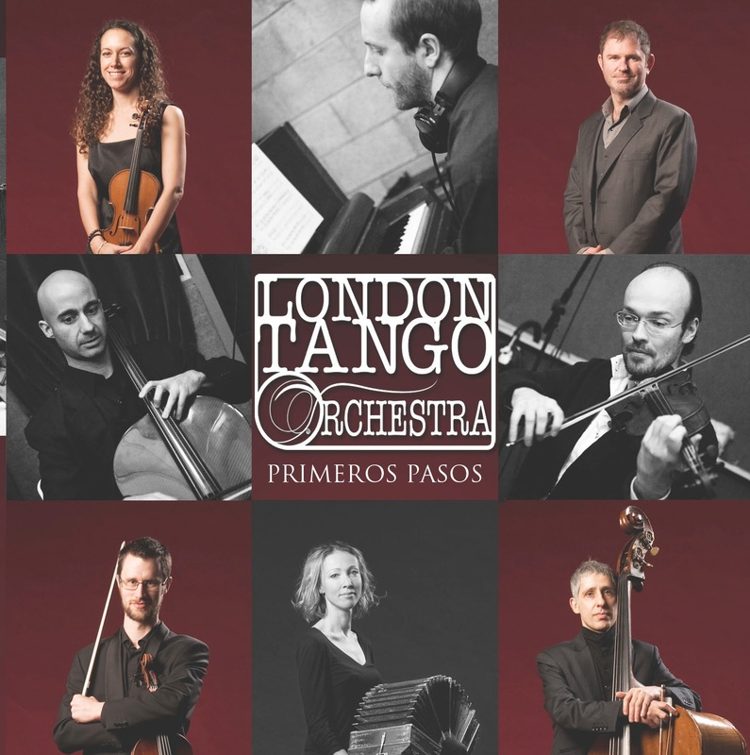

**TRACK LISTING**

1 - Malena  
2 - La Yumba  
3 - Pavadita  
4 - Con Toda La Voz Que Tengo  
5 - El Pollito  
6 - Milonga del Angel  
7 - Milonga Sentimental  
8 - Payadora  
9 - Romance de Barrio  
10 - La Cumparsita

**GENRE**

Tango/Latin

**SOUNDS LIKE**

Astor Piazzolla, Orquesta Tipica Imperial

“*Singer Guillermo Rozenthuler has a velvety, fluid voice, and the bandoneón and piano add rhythmic bounce. But string playing is at the heart of the LTO sound, from the utterly distinctive vertical string scrapes to swooping glissando flourishes.” Tim Woodall – The Strad*

*“There’s no questioning the virtuosic talents of the assembled pianist, strings and bandoneon players.” Chris Moss - Songlines*

**CONTACT**

Caroline Pearsall

[Caroline.pearsall@gmail.com](mailto:Caroline.pearsall@gmail.com)

00447974682565

0033631276175

**WEB**

thelondontangoorchestra.com

Facebook.com/londontangoorchestra

**BIOGRAPHY**

The London Tango Orchestra is the largest professional tango group in the country, a real "orquesta tipica" uniting leading UK tango musicians with players from Argentina. The orchestra was founded in 2009 by Caroline Pearsall and is the first of its kind in the UK.  
The orchestra performs music from the rich repertoire of tango, old and new, sharing its love of tango music through concerts, milongas and workshops and cultural exchanges between musicians from Europe, USA and Argentina.   
Their performances so far include the Southbank Centre, Flipside Festival with Leonardo Suarez Paz and Juan Jose Mosalini, Chelsea Arts Club, El Once Tango Club, Tango Federico, St James Church in Piccadilly, Ignite Concert Series at the Royal Albert Hall, the City of London Festival, Union Chapel, The Forge, Lets Tango UK Carnival Milonga, Tangoffs, Learning Tango, Tango Alchemy, Tango South, the Quarterhouse in Folkestone, Reading Tango Festival and Halle Tango Festival in Germany. They were part of a tango documentary filmed by the BBC in 2012 and several members recently appeared on the ITV series Mr Selfridge II.  
Recent radio plays include 103.2 DublinCityFM and Resonance FM.

They are currently planning a series of workshops and a tango show for 2017.

*Caroline Pearsall – Violin 1 & Director*

*Jamie Barclay – Violin 2*

*Barnaby Adams – Viola*

*Adam Spiers - Cello*

*Guillermo Rozenthuler - Voice  
Andrew Oliver - Piano  
Enrique Galassi - Bass  
Eva Berg – Bandoneon*

*(Bartosz Glowacki – Bandoneon)*